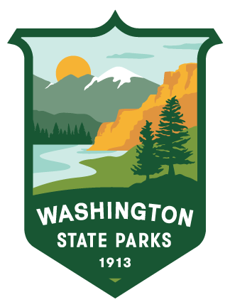

**2025 Park Host CAMPOREE**

# Fort Worden Historical State Park

October 6-8, 2025

**Registration Form**

# Park Host name (s): _______________________________________________________

# Address: ____________________________________________________________

# City: ____________________ State: ______ Zip Code: ________

# E-mail: ______________________________ Phone: ______________________

* **Registration is first come-first serve and space is limited.**

**Camping:** The park has reserved 25 partial utility (Power/Water) sites in the Forest Loop. The park also has one dump station. Maximum site length is 40 feet (limited availability). Electrical Service is 30-Amp.

Request Campsite:

Length of RV:

# **Housing:** There are a number of optional housing alternatives if needed.

# Request Housing:

# Arrival date: ____________ Departure date: __________

The Camporee will begin at 1pm on Monday October 6th and conclude on Thursday October 8th at 5pm with checkout on the 9th. Campsite fees will be waived for the Camporee October 6th-8th. Additional nights will be the responsibility of the individual(s). If you wish to extend your stay, please make your own reservations through [washington.goingtocamp.com/](https://washington.goingtocamp.com/).

***Registration closes August 30th.*** Return your registration via e-mail to [***paul.ruppert@parks.wa.gov***](mailto:paul.ruppert@parks.wa.gov)or mail to Washington State Parks Volunteer Program P.O. Box 42650, Olympia WA 98504-2650.