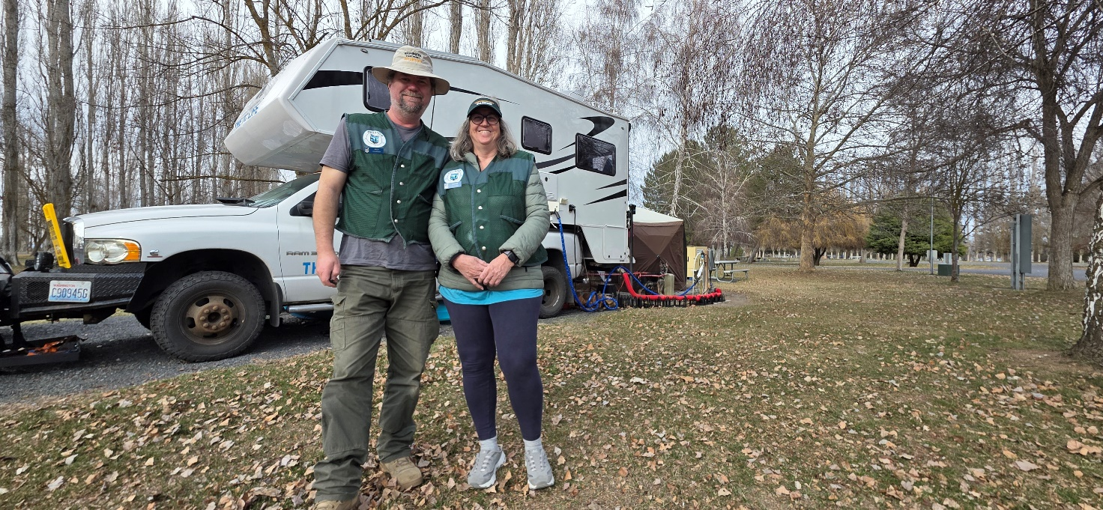As a state agency, Washington State Parks is legally required to provide all volunteers with workers’ compensation coverage (medical aid only) through the Washington Department of Labor and Industries (LNI). Total volunteer hours are reported to LNI quarterly to calculate insurance premiums. To ensure eligibility for the volunteer workers’ compensation coverage, all hosts are required to complete and submit a Volunteer Timesheet for Individuals (Form A-168) each month.

**HOST TIMESHEET TUTORIAL**

**How to Fill Out a Timesheet**

1. When you begin your volunteer service, you will be provided with a Volunteer Timesheet for Individuals (Form A-168) to log your hours.

Paper timesheets are available; however, the timesheet is also available electronically as a fillable Excel document that will calculate your total hours for you. Hosts are encouraged to fill out the timesheet in Excel using their laptop, notebook, or other mobile device, whenever possible. You can always get a copy of the timesheet from park staff.

1. Complete the top of the form. Be sure to include the following information (all other boxes are optional):
   * Park Name
   * Volunteer Name(s)
2. Complete Section A - Check the “Campground Host” or “Marine Park Host” box, as appropriate.
3. Complete Section B:
   * Fill in the Month and Year
   * Fill in the number of hours you worked per day. If you worked zero hours, leave the space blank.
   * If more than one person is hosting, please record your hours separately. Hours for Volunteer 1 should go on the top line and hours for Volunteer 2 should go on the bottom line.
   * Add up the total hours you worked. If you are using the Excel form, the spreadsheet will calculate your total hours for you.

**TIP:** *You may have to estimate the time you are performing some host duties. For example, sitting in your campsite having a cup of coffee would not count, but answering visitors’ questions while you drink that cup of coffee does.*

**REMINDER:** *Hosts are required to perform a minimum of 28 hours of service per week to receive maintenance in the form of a waiver of campsite/moorage fees.*

1. Complete Section C – Transfer the total hours for each volunteer to the corresponding “Host 1” and “Host 2” boxes under “**Host Services**.”

**TIP**: *All hours worked as a volunteer host are considered “Host Services” and are reported as such. Please* ***do not*** *divide or allocate your time into different categories (e.g., General Maintenance, Trail Maintenance, etc.).*

1. Signature – If filling out the timesheet electronically in Excel, a signature is not required.
2. Turn in your timesheet to your supervisor at the end of your volunteer service, or at the end of each month, whichever comes first.

If you use the Excel form, you can submit your electronic timesheet via email. Park staff will forward timesheets to the Volunteer Program in Olympia.