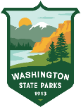 | WASHINGTON STATE PARKS & RECREATION COMMISSION  INFORMATION CENTER  Foster Family Pass – Verification Form

Applicant name

Signature of applicant | Date
I am one of the following (check the box that applies):
☐Kinship navigator
☐Group home official
☐Tribal government official
Verification
I certify the applicant named above has a child in their care and is responsible for that child through a kinship or caregiver relationship.
Name of official | Official’s position
Phone number | Organization
Signature of official | Date
For questions or assistance completing this form, please contact the Information Center at:

Phone: (360) 902-8844
Email: infocent@parks.wa.gov
Fax: (360) 586-6640

