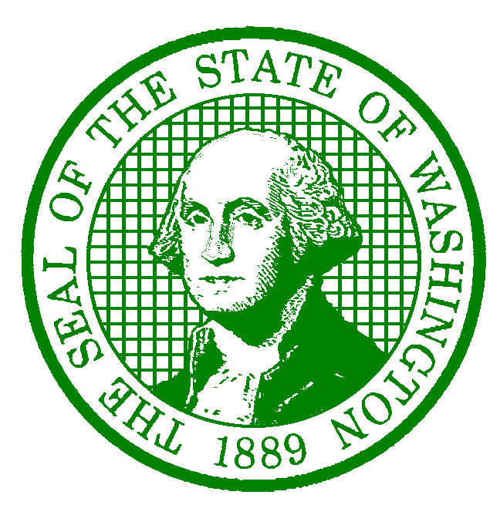

Diana Dupuis

Director

STATE OF WASHINGTON

WASHINGTON STATE PARKS AND RECREATION COMMISSION

# 1111 Israel Road S.W. · P.O. Box 42650 · Olympia, WA 98504-2650 · (360) 902-8500

## TDD Telecommunications Device for the Deaf: 800-833-6388

### [www.parks.wa.gov](http://www.parks.state.wa.us)

October 3, 2024

Update Comment Date Change Riverside State Park: Glen Tana

*Please note the comment period deadline for the proposed Amendment to Riverside State Park Classification and Management Plan (CAMP) to include the Glen Tana Property has been extended from September 30, 2024, to October 7, 2024.

Copies of the checklist and DNS are available at no charge on Washington State Park’s website at [http://bit.ly/ParksSEPA](https://gcc02.safelinks.protection.outlook.com/?url=http%3A%2F%2Fbit.ly%2FParksSEPA&data=05%7C02%7CNata.Hurst%40PARKS.WA.GOV%7C038729643d1a4379c9fa08dcd744399c%7C11d0e217264e400a8ba057dcc127d72d%7C0%7C0%7C638621935224787132%7CUnknown%7CTWFpbGZsb3d8eyJWIjoiMC4wLjAwMDAiLCJQIjoiV2luMzIiLCJBTiI6Ik1haWwiLCJXVCI6Mn0%3D%7C0%7C%7C%7C&sdata=IsYKq0jgmXEmkld5F8jPJEfzy6BbEQp4Q75Bi%2FvG3tw%3D&reserved=0). The public is invited to comment on this DNS by submitting written comments no later than October 7, 2024, to Kira Swanson at the address below.

Kira Swanson

Washington State Parks and Recreation Commission

220 N. Walnut Street

Burlington, WA 98233

Phone:   (360) 522-2287

Email:    [SEPA@parks.wa.gov](mailto:SEPA@parks.wa.gov)